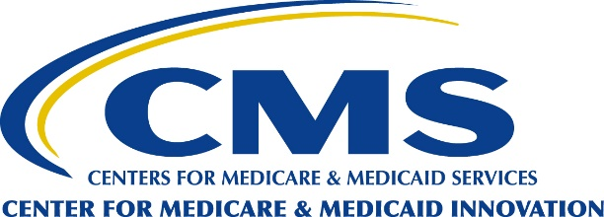
This letter is informational only. No action on your part is necessary.
Beneficiary Notification Letter
Your Team of Health Care Providers are
Working Together to Give You the Best Care

This notification is from the Centers for Medicare & Medicaid Services (CMS) to inform you that the hospital, Ohio Valley Surgical Hospital, has been selected to participate in a mandatory program called the "Transforming Episode Accountability Model" (TEAM). A CMS model is a trial program, and a way of testing how health care can be improved for people with Medicare and Medicaid. In this model, selected hospitals (referred to as "TEAM participants") will coordinate care for beneficiaries like you with original Medicare who are undergoing certain surgical procedures included in the model. TEAM participants are accountable for the cost and quality of care from surgery through the first 30 days after you leave the hospital.

TEAM participants can choose to work with health care entities, such as skilled nursing facilities, home health agencies, doctors, and other healthcare workers or organizations who are also helping Medicare patients. These helpers are called “TEAM collaborators”. TEAM participants can set up financial arrangements to share extra money they get from Medicare with TEAM collaborators.

Medicare believes that when hospitals and other healthcare entities work together, patients get better care. This teamwork can also help save money, for example, by helping patients avoid going back to the hospital when it’s not needed.

You can find the list of healthcare entities working with Ohio Valley Surgical Hospital as TEAM collaborators here: None

What do I need to know about TEAM?

TEAM aims to improve the patient’s experience from surgery through recovery by supporting the coordination and transition of care between providers to reduce avoidable hospital readmissions.

The five surgical procedures in the model are:
- lower extremity joint replacement
- surgical hip femur fracture treatment
- spinal fusion
- coronary artery bypass graft
- major bowel procedures

You will have all the same Medicare benefits, rights, and protections.
Medicare will continue to cover all your medically necessary services. However, individual beneficiaries cannot opt out of the model when they receive hospital services from a TEAM participant, such as Ohio Valley Surgical Hospital. As a Medicare beneficiary, you will keep your freedom of choice and may seek care with a different hospital that is not a TEAM participant.

Health care providers and suppliers who are enrolled in Medicare and are TEAM participants will submit their Medicare claims as they have always done. Even though Medicare may provide additional payments to a hospital that is a TEAM participant, the amount you pay will not change.

Information sharing helps coordinate your medical care.
Your medical records and Medicare claims data, such as the Medicare Beneficiary Identifier, date of birth, provider name, date of service, diagnosis, and procedure codes, may be shared with your health care team to provide you with better, safer, and more coordinated care. When all your doctors and clinicians in the hospital and/or clinics you visit can see the same test results, treatments, and prescriptions, they can work together to support your health goals. More coordination helps prevent medical errors and adverse drug interactions. You may save time, money, and frustration by avoiding repeated tests and appointments.

Medicare will always protect the privacy of your health information. Your information is kept private by law.

Ohio Valley Surgical Hospital has an electronic health information system with a "Patient Portal" that provides you with easy online access to your medical records. The instructions for access are provided below:

Accessing Your Health Information through Ohio Valley Patient Portal:
You may view portions of your medical record through the Ohio Valley Surgical Hospital patient portal at https://wwwovsurgical.com/patients- visitors/ov-patient-portal/.
The instructions to download your medical records are as follows:
- Click on Health Record
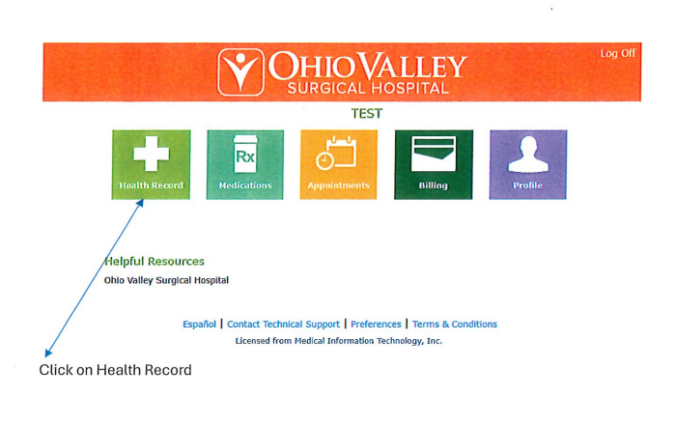
- Click on Download Medical Record

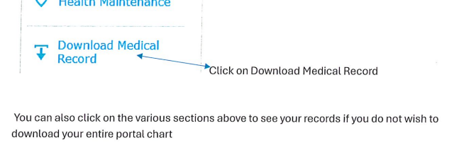
- You will see a message that says the medical record file is being processed.
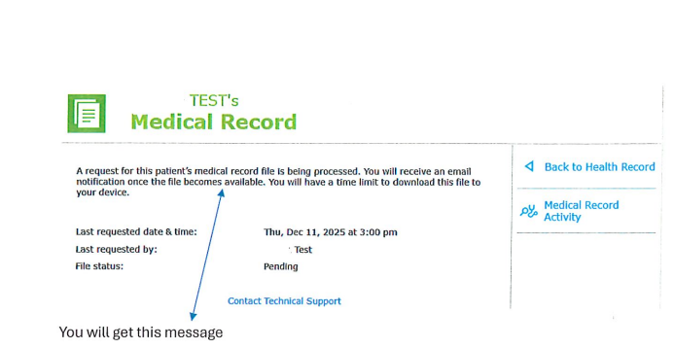
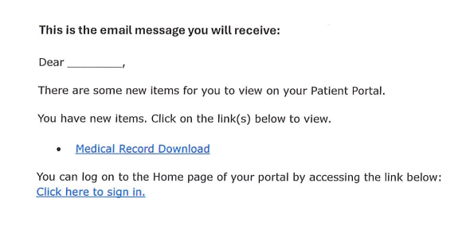
- You will receive an email when the file is available
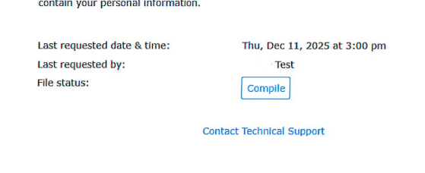
- Once you click download select compile to start gathering your medical information into a Zip file format
- Select the download button to save the zipped file to your selected location. Check for a default location.
- Once the download is complete, unzip the file by double clicking or right clicking the file.
- The zipped file will contain two types of files, those that you can read directly, and other types that can only be read by computers (used when importing this information into other computer systems)
- Caution!! Anyone with access to your computer or device where you downloaded your medical record could potentially see the downloaded files that contain your personal information.
Medicare also provides a separate online service, available through Medicare.gov, where beneficiaries can view, download, and share their Medicare claims information.


You have a legal right to receive your personal health information.
Blue Button is one way this information may be made available to you.
Blue Button refers to a feature on a patient portal or health care website that allows individuals to electronically access and download their personal health information, like medical records, medications, allergies, and lab results, in a standardized format, enabling them to easily view, share, and manage their health data with different providers or caregivers. The term signifies your ability to download your health information by clicking a Blue Button icon on the health care provider's website. When navigating the "Patient Portal," look for the Blue Button icon, and take action to gain access to your personal health information.
If you have concerns or complaints about your care, you can:
- Talk to your doctor or healthcare provider.
- Contact your local Quality Improvement Organization (QIO). The QIO program is dedicated to improving the quality of health for Medicare beneficiaries. To get your QIO's phone number, call 1-800-Medicare.
- Call the 1-800-MEDICARE (1-800-633-4227) helpline 24 hours a day.

Where can I learn more about TEAM?
Visit the TEAM web page to view the list of hospitals participating in the model (the TEAM participants), details about the model design, and Frequently Asked Questions (FAQs).
https://www.cms.gov/priorities/innovation/innovation-models/team-model

